1. **Agenda:**
   1. In this lecture, we are going to integrate library event producer into Library Event Controller.

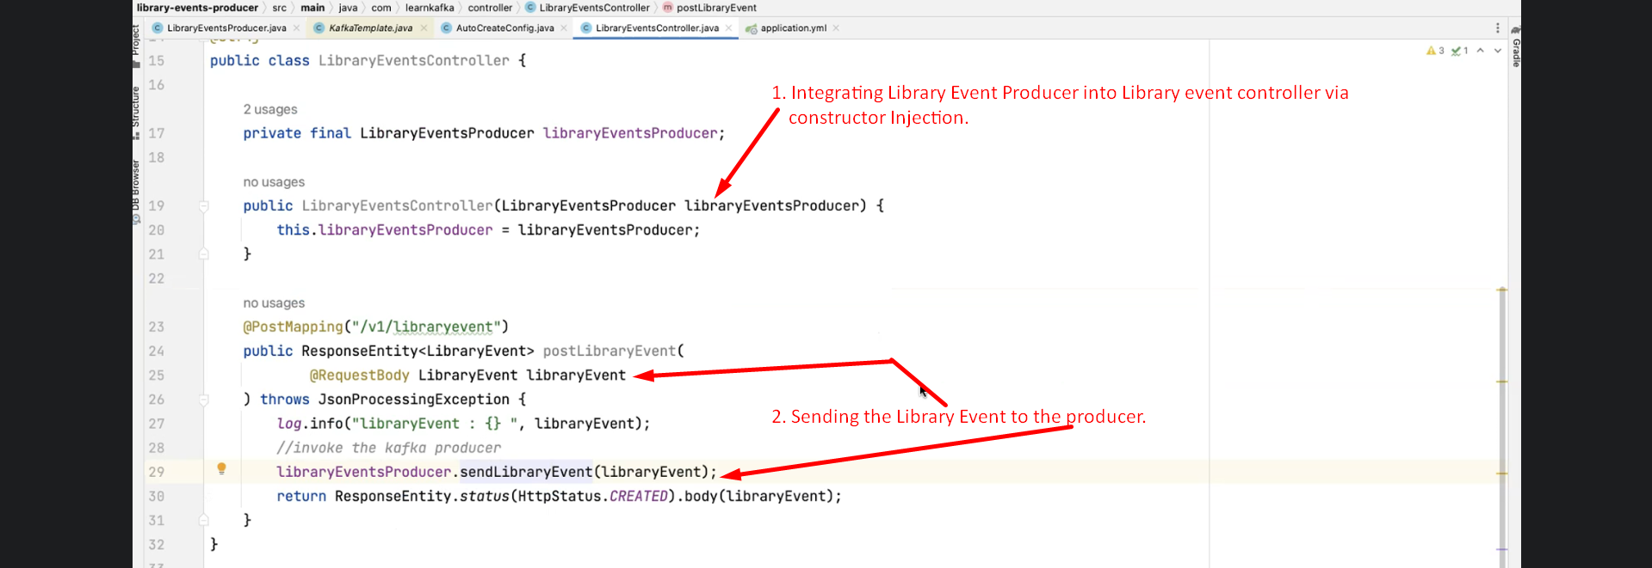

1. 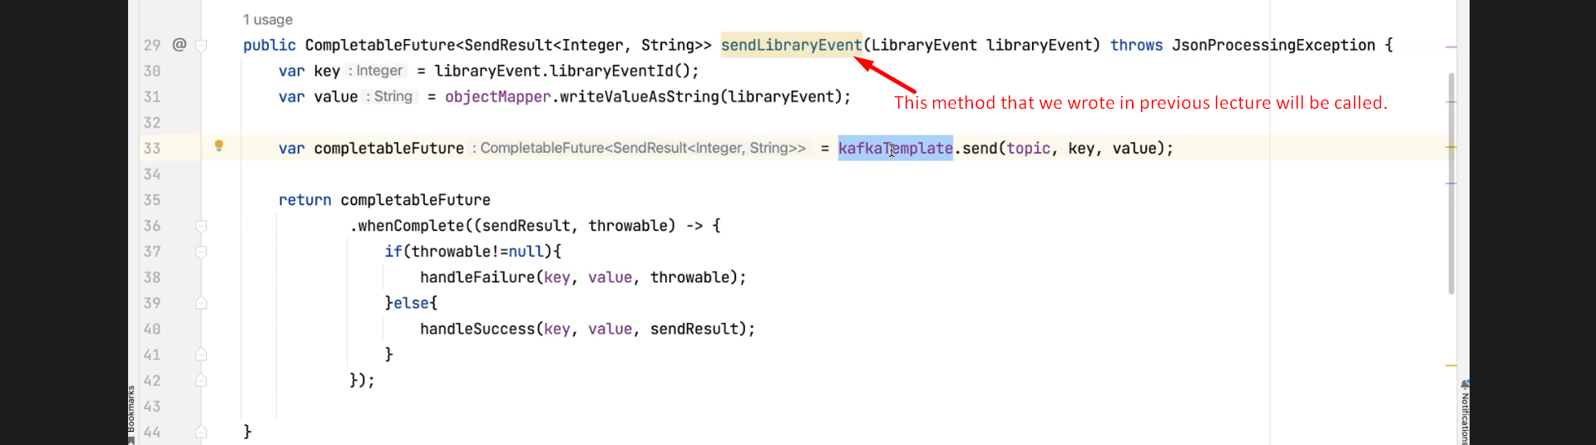
2. **Sending POST Request.** 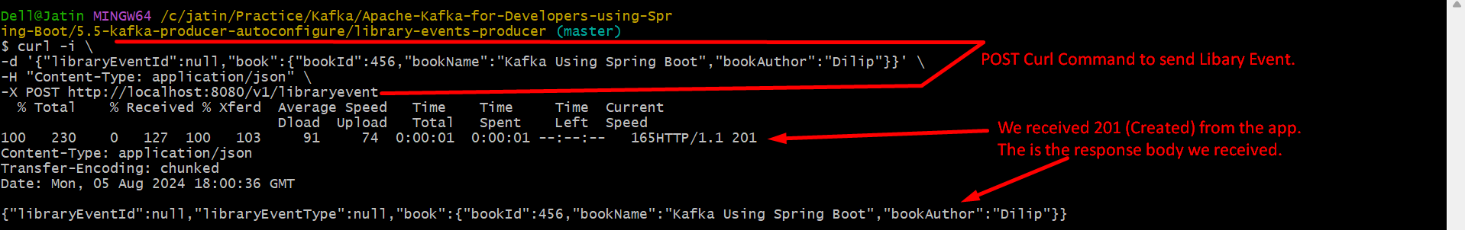  
   CURL command can be collected from here.   
   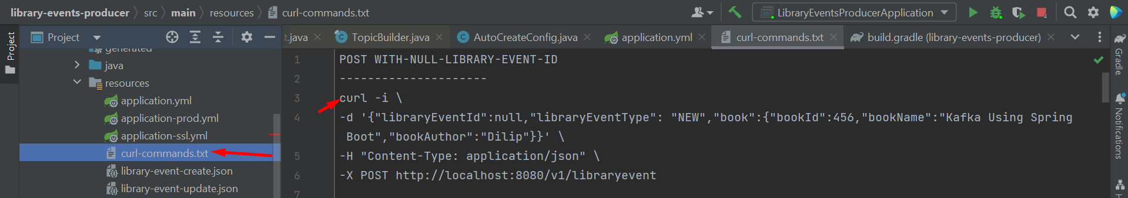
3. The console output when Kafka Producer makes initial connection for metadata with Kafka Cluster.   
   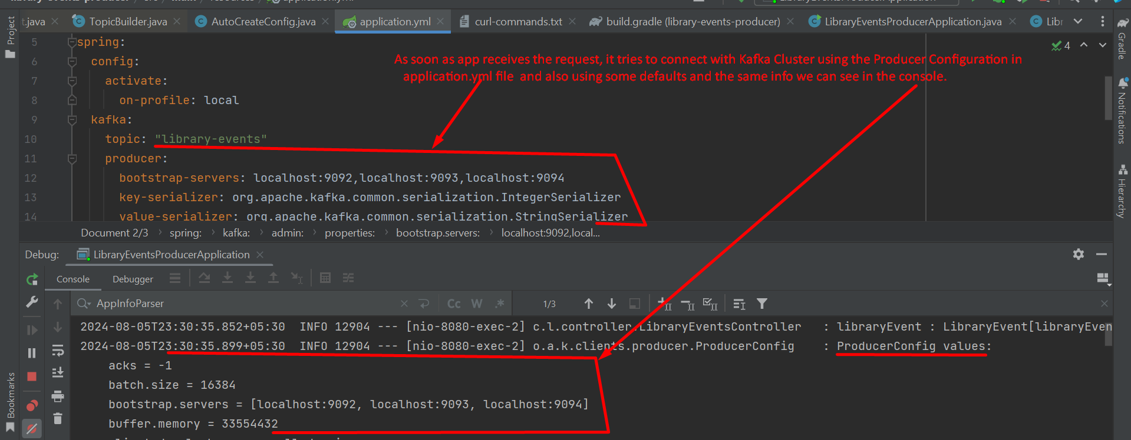
4. Successful Log after sending msg to Kafka Cluster.   
   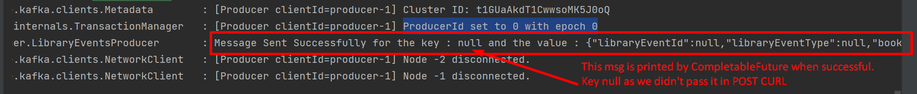
5. There are some error scenarios which we will cover in a separate videos later on.